Affiliation No.:- 531506
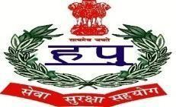
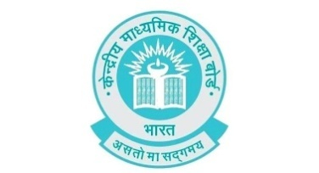

D.A.V. POLICE PUBLIC SCHOOL
POLICE LINES, SONIPAT-131001

PTA Executive Committee

SESSION (2022-23)

S.No. | Parent Representattive | Contact No. | Teacher Representative | Contact No.
1. | Mr. Jitender | 8571981145 | Ms. Rama | 8396859155
2. | Mr. Ramesh | 9466548188 | Ms. Jyoti Sharma | 7988587006
3. | Mr. Sunder Singh | 9671220064 | Ms. Jyoti | 7206881663
4. | Mr. Rakesh | 9992684999 | Ms. Pooja | 9996353637
5. | Mr. Bintu | 9728888488 | Ms. Sarita Khatri | 7011099298
6. | Mr. Parveen | 7206020995 | Ms. Kulwanti | 9518148909
7. | Mr. Sudhir | 8295059900 | Ms. Manusmriti | 7015692310
8. | Mr. Satbir | 9812969452 | Ms. Bhawana | 9355999370
9. | Mr. Naresh | 8860755132 | Ms. Pooja Sharma | 8307256078
10. | Mr. Jitender | 9150234000 | Ms. Renu | 8398934424

